Price and Performance in the Large Language Model Market: Exploratory Evidence

Abstract
This study analyzes the price-performance relationship in the Large Language Model (LLM) market using **1,088 model-month observations representing **267 models from 30 developers between November 2022 and March 2026 [**Update for 6 months]. The price elasticity with respect to performance ranges from 3 to 3.9: a 1% improvement in MMLU Pro is associated with a 3%+ increase in price. Open-source models are priced about 60% below proprietary models with comparable performance on average. Frontier models command a premium averaging 80% above that implied by measured performance. Performance-adjusted prices decline substantially over time; the companion trend specifications imply annual declines averaging **** [We don’t have the regression] and there is a significant price disparity among developers, reflecting their different reputations and brands.

Keywords: Large Language Models, AI Economics, MMLU Pro, Price Elasticity, Open Source.

Introduction

[Literature skipped]

The rapid advancement of Large Language Models (LLMs) represents one of the most significant technological transformations of the 21st century. From powering enterprise applications to enabling consumer products, LLMs are becoming central to the digital economy. Recent theoretical work has begun to address the economics of LLM pricing, including optimal token allocation and fine-tuning strategies (Bergemann et al., 2025), competition dynamics in generative AI markets (Mahmood, 2024), and the relationship between scaling laws and market structure (Korinek & Vipra, 2025). As the market matures, understanding the economic dynamics governing LLM pricing becomes crucial for strategic decision-making across multiple stakeholder groups: AI developers positioning their products, enterprises procuring AI capabilities, investors evaluating market opportunities, and policymakers crafting regulatory frameworks.
Despite the market's rapid growth, systematic empirical analysis of LLM pricing dynamics remains limited. Previous work has focused primarily on capability benchmarking (Chang et al., 2024; Wang et al., 2024) or technical performance, with relatively little attention to the economic relationships governing market prices. The question of whether AI foundation models constitute a natural monopoly (Schmid et al., 2024) was actively debated, with implications for competition policy. Meanwhile, the rising costs of training frontier models (Cottier et al., 2024b) and the economic value of training data (Kandpal & Raffel, 2025) create cost structures that may influence market pricing. This gap is particularly concerning given the market's significant size and growth trajectory, the substantial heterogeneity in pricing across providers (Velasco et al., 2025), and the policy implications of AI accessibility and open-source alternatives (Korinek, 2025).
[Replace the below by simpler objectives] // (done)
This research addresses three fundamental questions:

- First, what is the relationship between an LLM's measured performance and its price per token, and does the market reward performance improvements proportionately or with increasing returns?
- Second, how do business-model choices - open-source versus proprietary release - and product positioning at the top of the performance distribution affect pricing once performance is held constant? In this context, we estimate the magnitude of the open-source discount at equivalent performance and examine how it has evolved.
- Third, how have performance-adjusted prices evolved over time, and is the pricing structure stable across the pre- and post-2025 segments of the sample?

Beyond these focal questions, we document substantial heterogeneity across developers. As one might expect, providers differ in how they price comparable models; we report this heterogeneity descriptively rather than treating it as a separate hypothesis.
Our empirical analysis uses panel regressions with standard errors clustered by developer. We construct a dataset of 267 unique LLM models from 30 developers, observed monthly from November 2022 to March 2026. The 12-month panel contains 1,123 model-month rows; after excluding 35 rows without MMLU Pro, the regression sample contains 1,088 model-month observations. This comprehensive dataset enables robust identification of pricing relationships while controlling for unobserved heterogeneity across developers and time periods.

Related Literature [Skipped]
Economics of AI and LLMs: This paper contributes to the emerging literature on the economics of artificial intelligence and large language models. Bergemann, Bonatti, and Smolin (2025) develop a theoretical framework for optimal LLM pricing, analyzing token allocation and fine-tuning strategies. Mahmood (2024) examines competition dynamics in generative AI markets, providing insights into strategic pricing behavior. Korinek and Vipra (2025) investigate the relationship between scaling laws and market concentration, raising important questions about whether frontier AI development leads to natural monopoly conditions. Schmid, Sytsma, and Shenk (2024) directly address whether foundation models constitute natural monopolies, with significant implications for antitrust policy.
Technology Pricing and Diffusion: Our work extends the technology-pricing literature to the LLM context. In the full sample, the two preferred trend specifications imply annual capability-adjusted price declines of 58.9% to 64.8%. This rapid price deflation situates LLMs among the fastest-diffusing technologies in economic history, comparable to early semiconductor pricing dynamics. These are in-sample conditional associations, not forecasts of how quickly a particular model or capability tier will reach a given price.

2. Research Hypotheses
We study the drivers of LLMs’ per-token pricing cross-sectionally and over time. Comparing LLMs at a given point in time, the key price driver is inference performance or capability (sometimes referred to as intelligence). We obviously expect a positive relationship between price and performance. Hypotheses 1 and 1A elaborate on the price-performance relationship and on the price elasticity with respect to LLM performance. Further, we expect open-source LLMs to be priced below proprietary LLMs after controlling for performance. This leads to Hypothesis 2. At the time-series level, we expect LLM token prices to decline over time, following the cost decline trend for GPUs (Hypothesis 3). We elaborate on our hypotheses below.

Hypotheses 1 (Price elasticity) and 1A (Frontier model premium):
Hypotheses 1 and 1A follow from economic analysis, LLM experience and simple logic. In a classic paper, Mussa and Rosen (1978) studied a firm that sells multiple products with different levels of quality (here, LLM performance) at different prices. This results in a cross-section of vertically-differentiated products, each characterized by its levels of quality and price. They find that if we plot price as a function of quality, the resulting curve is convex, namely, price increases at an increasing rate as quality increases. This implies that above a threshold level of quality, the measured price elasticity with respect to quality is greater than unity. This price structure achieves two strategic maxims: first, it allows the firm to extract more surplus from high-end buyers. Second, it increases the separation between high- and low-end buyers so the firm can price-differentiate more effectively.
Within the family of constant-elasticity curves, the price-quality curve is increasing and convex if and only if its elasticity is greater than unity. Jones and Mendelson (2011) studied the development and pricing of information goods with multiple competing firms, each setting its own quality and price. In their duopoly model, they find that the relationship between price and quality is represented by a constant-elasticity curve with elasticity 2 (while the paper doesn’t explicitly state the elasticity, this is directly implied by their results). Wei and Nault (2006) found a similar result for a duopoly. Jones and Mendelson (2011) solved the problem numerically for an oligopoly with more firms, finding that in all cases, the elasticity is greater than 1 with its exact value depending on problem parameters.
These results are also supported by earlier studies of the economics of software quality. Similar to other types of software, quality has a large downstream effect on productivity and value when enterprises deploy LLMs, and failure can be very costly. The cost of the software itself (or the tokens for an LLM) is typically only a fraction of the overall cost and value of the process it supports. Therefore, buyers are willing to pay disproportionately more for higher quality, particularly at the high end. Slaughter, Harter, and Krishnan (1998) and Harter, Krishnan, and Slaughter (2000) make and quantify this point, which has since been accepted widely, in the context of software reliability. Krasner (2022) estimated for the Consortium for Information & Software Quality (CISQ) that in 2022, the cost of poor software quality in the United States was $0.9 ($2.4, respectively) Trillion excluding (including, resp.) the cost of technical debt. Further, CISQ found that the cost function is asymmetric because software failures can lead to total project abandonment which is associated with very high costs, and higher-quality software reduces the probability of incurring such losses.
These considerations apply to LLMs and software alike. While we are not aware of studies that examined the elasticity of LLM token prices with respect to performance, we expect LLMs to follow the same logic. Specifically, enterprise use of LLMs (to be distinguished from subscription-based consumer and prosumer use) plugs them into repeatable business processes whose value substantially exceeds the cost of the tokens they use. If successful, a relatively small (albeit not negligible) payment to the LLM provider translates to a substantial value for the enterprise. This leverage results in a high elasticity of demand with respect to inference performance. For example, if a 1% performance improvement saves the enterprise 5% in labor costs, the enterprise should be willing to pay far more than 1% for that performance improvement. Further, as discussed above, project failures may be very costly, so enterprises should be willing to pay more than proportionately to increase the probability of success. If performance improvement leads to a 1% increase in the probability of project success, that 1% is multiplied by the value of the project, not by the cost of the software or tokens used to enable the project.
This leads to:
H1: LLM token prices are increasing and convex functions of LLM inference performance. Within the family of constant-elasticity functions, the elasticity of this function is greater than 1.
The above considerations also suggest that top-performing LLMs should command an additional price premium over and above the nominal price-performance curve. Further, at this early stage of development, multiple firms race to achieve dominant positions in their respective markets by using AI. This creates a race where a higher-performance LLM can increase the probability that the firm will become dominant in its market. The dynamics of such R&D races has been studied in Loury (1979), Dasgupta & Stiglitz (1980), Reinganum (1983), and dozens of follow-up papers. While each paper develops a different model of this R&D race, a key common insight is that when there is a number of performance levels the firm can invest in, improving performance at the lower levels gives the firm only an incremental advantage implying an incremental price increase (which, in our case, is reflected in the price elasticity), whereas getting to the top level increases the likelihood of (or, in some models, results in) market dominance, which means that there’s an upward jump in the firm’s willingness to pay for performance: market dominance creates a step function in the firm’s expected profit over and above the incremental profits obtained through investments at lower levels of quality. As a result, we expect to see a discontinuity whereby top performance commands an additional price premium. Since different developers cater to different markets, have different brands and focus on different LLM features, we operationalize our hypothesis by considering frontier models which we define as the top-performing models for each major developer.
In addition to the above considerations, a developer’s frontier model faces (for a period of time) less competition than its other models. By definition, it is ahead of the developer’s other models and it typically has unique, advanced features that set it apart and were developed because they were deemed important to customers. Further, unlike mid-tier models, the frontier model receives effectively free advertising as it is featured more prominently on the developer’s website, published case studies, press and company events and presentations. In addition, early-adopting developers are attracted to the more capable frontier model which allows them to create more differentiated products. These considerations give rise to the following hypothesis:
H1A: Frontier models command an additional price premium.

Hypotheses 2 (Open Source discount)
We posit that open-source LLMs are priced meaningfully below proprietary LLMs with equivalent performance levels. The two regimes monetize differently: proprietary firms charge for the software itself – through license fees, hosted access, per-seat subscriptions, or, in the case of LLMs, per-token fees – while firms that commercialize open-source software don’t charge for the software and instead monetize complements such as services, support, and hosted infrastructure (Lerner and Tirole, 2002, 2005). A few models (Lanzi (2005), Lee and Mendelson (2008), Casadesus-Masanell and Llanes (2011), Zhu and Zhou (2012), August et al. (2021)) formalize this asymmetry in models where a proprietary incumbent competes with one or more open-source firms that monetize via complementary services. They show that the proprietary price is compressed in equilibrium by the presence of a free license alternative, in particular when there are multiple open-source competitors. Together, these models identify two drivers of the open-source discount: the open-source price is structurally lower, and the proprietary price is compressed by competitive pressure from the open alternatives. These results apply directly to the LLM market, and our first hypothesis is:
H2: The per-token price of open-source LLMs is lower than the per-token price of proprietary LLMs with comparable characteristics.
Early evidence from the LLM market is consistent with the hypothesized price compression. Bristot (2025), Demirer et al. (2025), and Nagle and Yue (2025) report proprietary-to-open-source price ratios of roughly 6:1 to 10:1 in cross-sectional snapshots, with proprietary list prices declining sharply once comparable open-source models reach the market. Unlike our analysis, however, these exploratory comparisons do not control for performance. As a result, they tend to exaggerate the open-source discount. Our results show that this exaggeration is substantial.

Hypothesis 3 (Price Decline)
We hypothesize that after controlling for performance, the average price per token declines over time. Four mutually reinforcing mechanisms — algorithmic efficiency gains, GPU price-performance improvements, entry by open-source challengers which compress provider markups, and learning effects from earlier deployments — jointly tend to drive the price-performance curve down. This hypothesis is straightforward and has been confirmed by multiple studies. What we are interested in is the magnitude of the price decline. The price decline rates reported in earlier studies are insufficient as they don’t control for the factors analyzed in our study.
Our hypothesis is
H3: Controlling for model performance, the price of LLM inference declines over time across the overall market.
While the hypothesis is not surprising, our main aim is to quantify the market-wide price declines.

3. Data and Methodology

3.1 Data Sources and Sample Construction
Our dataset combines publicly available information on LLM specifications, MMLU Pro performance, release dates, and API token prices, from November 2022 to March 2026. To examine whether pricing relationships changed as the market matured, we also divide the sample into two equally-sized subsamples, from November 2022 through August 2025, and from September 2025 through March 2026. Exhibit 1 summarizes the sample characteristics for the full period and for both subperiods.
Models enter our sample when they have a documented API price, an MMLU Pro score, an identified developer and release date, and they fall within the November 2022–March 2026 window. We exclude products available only through undisclosed enterprise contracts and specialized systems that are not comparable to the benchmark.

3.2 Data Description and Key Variables
Our primary data source is Artificial Analysis (artificialanalysis.ai), which tracks model specifications, benchmarks, and API prices. We supplement missing or low-precision MMLU Pro values with published benchmark tables, model documentation, and public model cards. Our sample includes 267 unique models from 30 developers, covering the major commercial providers and significant open-source contributors. We don’t make market-share claims because the dataset measures available models and prices rather than API transaction volumes.
The variables used in the analysis are listed in Exhibit 2 and discussed briefly below.

Variable Definitions
Dependent Variable—Log(Price), where Price is the simple average of the posted input and output prices per million tokens, expressed in U.S. dollars (Price = (Input Price + Output Price) / 2). The dependent variable is the natural logarithm of this average. The log transformation reduces right skew and makes the coefficient of Log(MMLU Pro) directly interpretable as a price-performance elasticity.

Independent Variables:
Log(MMLU Pro): Our performance measure is MMLU Pro. It extends the original MMLU benchmark with more difficult questions and greater discrimination among high-performing models (Wang et al., 2024). We take its natural logarithm so the coefficient is an elasticity.
MMLU Pro is determined by a model’s architecture, training data, and training procedures determined before the contemporaneous pricing observations used in the panel. Current token prices therefore cannot causally change the model’s previously-realized benchmark score. We nevertheless interpret the estimates as conditional associations because unmeasured capabilities may be correlated with both MMLU Pro and Price.

Open Source (OS): An indicator equal to 1 for models classified as open-weight/open-source and 0 for proprietary models. We checked each model’s licence against the vendor’s announcement or its published model card. For the most part, developers publish either open source or proprietary models, although some proprietary developers have published open source versions of their models. The incidence of these cases, however, is too limited to achieve meaningful statistical results.
Model Developer: The organization that releases and maintains the model. Developer indicator variables control for time-invariant differences in brand, cost structure, customer mix, and commercial strategy.
Frontier: A binary indicator equal to 1 for the highest-MMLU-Pro model within a developer in a given month when the developer has at least three distinct models in the relevant estimation sample *** NOT IN THAT MONTH?***, and 0 otherwise. **** It is reassigned separately within each subperiod. *** Not each month?****

Panel Data Construction

Our dataset was constructed in two stages. We first collected prices manually from public provider sources each month. We later adopted Artificial Analysis bulk downloads that included all new models and model price changes. Artificial Analysis executives explained that almost always, existing model prices change only when a new model is introduced. This meant that we could fill in existing model prices based on their earlier prices until a new model was introduced. We thus carried each existing model price forward until the developer’s next eligible release in a later month for at most 6 months. To test this method, we compared the resulting prices to our monthly manually-collected prices. With 290 matched observations, the correlation between the prices obtained under the two methods was 0.986 ***UPDATE FOR 6 MONTHS***. The average relative mean absolute difference was 3.6%**UPDATE*** with a signed mean of ***; these differences were not statistically different from zero (paired t-test p = .76 ***UPDATE***). Our raw panel comprises 1,123 ***UPDATE*** model-month rows. Thirty-five ***UPDATE*** rows lack MMLU Pro and cannot enter the price regression, leaving ***1,088 observations representing ***267 unique models and 30 developers. Appendix ** provides robustness checks for our results, showing them with a cutoff of 9 or 12 months.

Descriptive Statistics
Exhibit 3 presents raw-variable descriptive statistics for the full estimation sample *** IS THIS 1,088 or 1,123? ***and for each subperiod. The full-period median price is ***$1.00 per million tokens and the median MMLU Pro score is ***0.76. Prices range from $0.03 to $50.00 per million tokens, demonstrating substantial variation before performance and developer characteristics are controlled for.

Model Specifications
We estimate two principal panel regression specifications on the full sample and separately for our two subperiods.
Specification 1 (Market-wide pricing with Open Source + Month Fixed Effects):
Log(Price) = β₀ + β₁ ᐧ Log(MMLU Pro) + β₂ ᐧ OS + β₃ ᐧ Frontier + Month FE + ε.
Month FE are indicators for each observation month, controlling for monthly fixed effects. November 2022 is the omitted full-period baseline.

Specification 2 (Developer FE + Month FE):
Log(Price) = β₀ + β₁ ᐧ Log(MMLU Pro) + β₂ ᐧ Frontier + Month FE + Developer FE + ε.

Specification 2 adds developer fixed effects while dropping OS, which is largely determined by the developer.

We estimate the coefficients by ordinary least squares and report standard errors clustered by developer. This permits arbitrary heteroskedasticity as well as correlation among observations from the same developer. The full sample contains 30 developer clusters; the two subperiods contain 14 and 29 clusters, respectively. Tests and confidence intervals use t-tests with G − 1 degrees of freedom, where G is the number of developer clusters.

Results

Exhibit 4 reports the results for our full-period specifications. **** GENERAL COMMENTS ON THE RESULTS *** As one might expect, there is a high degree of heterogeneity across developers: the developer fixed effects explain ****** ADD TO THE EXHIBITS PERCENTAGE OF VARIANCE EXPLAINED BY Developer FE***.
We present our results by our main hypotheses.

Hypotheses 1 and 1A (Elasticity and Frontier premium)
The price elasticity with respect to performance ranges between 3 and 3.88; both estimates are strongly statistically significant (p < .001) and the difference between them is insignificantly different from zero. Thus, a 1% increase in MMLU Pro is associated with approximately a 3%-3.9% increase in price, holding the other factors constant. The elasticity is well above unity in both specifications, supporting H1.

The Frontier coefficient falls from about 1 in Specification 1 to about .6 after developer fixed effects are added (p = .002 and p = .013 ***UPDATE). In percentage terms, these coefficients correspond to frontier model premia of approximately 180% to 280% beyond the price implied by measured performance and the other controls. The positive and statistically significant estimates support H1A. The smaller coefficient in Specification 2 is to be expected, as part of the market-wide frontier premium comes from developer-level pricing differences.

For the full-sample mean price of approximately $3 *** UPDATE for 6 months *** per million tokens and a mean MMLU Pro score of about 0.7, increasing performance by ten percentage points to 0.8 increases Log(MMLU Pro) by Log(0.8/0.7) and, at the full specification (2), predicts a 52% price increase to about $4.55. Frontier status then operates as an additional multiplicative premium.

Hypothesis 2 (Open Source discount)

Specification 1 is designed to estimate the open source effect. The OS coefficient is -0.94, corresponding to an approximate 60% discount relative to proprietary models with comparable characteristics. The estimate is both economically and statistically significant (p = ***): H2 is supported.

Hypothesis 3 (price decline)

H3 predicts that performance-adjusted inference prices decline over time. Exhibit 5 plots the month fixed effects, which correspond to the time series of Log(Price) over time, from both specifications, with a zero baseline at the beginning of the sample period. The estimates show irregular behavior in 2023 but then consistent price declines through the end of the sample period: there is a pronounced downward trend in the price of a given measured capability. Over the entire sample period, H3 is strongly supported by the data.

One exception is the increase in performance-adjusted prices in mid-2025. This time period coincides with the increased use of reasoning models, which had both higher performance and a higher price. Realizing that reasoning models could become overly expensive, enterprises opted for an arbitrage between reasoning and non-reasoning models, which led developers to increase the prices of their non-reasoning models to channel users back to their reasoning models. For example, Gemini Flash 2.5 launched with two versions, “thinking” and “non-thinking,” with a significant price difference “which led to developer confusion,” according to Google. Google then increased the “non-thinking” to match the “thinking” price, apparently to reduce arbitrage opportunities (Malick & Kilpatrick (2025)).

To directly estimate the rate of price decline, we estimated the model

Log(Price) = β₀ + β₁ ᐧ Log(MMLU Pro) + β₂ ᐧ Frontier + β₃ ᐧ T + Developer FE + ε,

where T is time (in months). The results are in Exhibit **.*** WE ACTUALLY DON’T HAVE THE RESULTS FOR THIS MODEL**** The coefficient β₃ is negative and significant, implying a price decline of ** per month, close to our earlier estimates.

We conclude that token prices decline on average by about 5% a month, or 45% annually. Controlling for capability, they are halved in about 14 months on average – faster than Moore’s Law for semiconductors but not as fast as some commentators have suggested.

Subperiod Analysis

To examine the robustness of our results, we re-estimated our models over two subperiods, November 2022-August 2025 (Subperiod 1) and September 2025 to March 2026 (Subperiod 2). Subperiod1 contains *** observations and 14 developers; Subperiod 2 contains *** observations and *** developers. Thus, each subperiod contains about half of our data points. Exhibit 6 shows the estimation results for the two subperiods. The results are generally consistent with the full-period results.

Frontier status is reassigned within each subperiod ***WHY? – LET’s DISCUSS***.

There are two notable differences, however. First, in the full model (Model 2, with developer fixed effects), the price elasticity with respect to product capability is more than twice as high in Subperiod 2 compared to Subperiod 1. Second, the Frontier premium, which was large and significant in Subperiod 1 (****, t=***) becomes smaller and statistically insignificant in Subperiod 2. The two differences may be related, reflecting the fact that enterprises have become more knowledgeable and analytic: they are willing to pay more for actual performance and capability at the expense of brand and established reputation, and they find ways to pay less for “vanilla,” often open-source LLMs that perform basic functions such as summarization and review. This translates into higher price elasticity and a lower Frontier premium. In fact, LLM gateways allow enterprises to automatically evaluate the price-performance tradeoff for different tasks and to route each task to the appropriate LLM. Such performance-based evaluations are expected to increase price sensitivity and reduce brand premia. Indeed, the enterprise AI gateway market increased from $1.87 billion in 2024 to $3.16 billion in 2026, and is expected to grow 30% a year.
In essence, as buyers become better-informed about actual performance, they rely less on reputation and brand and more on actual performance. As a simple illustration, if we regress Log(Price) on Log(Performance) but the buyer estimates Log(Performance) with an error ε whose variance is v_{ε} and the variance of Log(Performance) is v, then the elasticity of price with respect to performance will be scaled down by v_{ε}/(v+ v_{ε}). As buyers become more sophisticated and discerning, v_{ε} decreases and the elasticity increases.

This phenomenon has been studied previously in product markets. Wolinsky (1983) shows that when consumers have imperfect information about quality, the price markup charged by producers reflects the quality of consumer information: the poorer the information, the higher the mark-up. Bagwell and Riordan (1991) show that when product quality is highly ambiguous, high-quality firms overprice their product to signal a higher quality, but as buyers become better-informed, the high-quality prices decline to reflect their actual level of quality. Diehl, Kornish and Lynch (2003) show both theoretically and via an experiment that “smart agents” that screen products for quality (analogous to LLM gateways) increase consumers’ price sensitivity to quality. Bronnenberg, Dubé, Gentzkow and Shapiro (2015) find that well-informed buyers are less likely to pay extra for national brands. For example, pharmacists choose national over store brands only 9% of the time compared to 26% for the average consumer, and for pantry staples, chefs’ purchases of national brands are 12% lower than similar nonchefs. Luca (2016) studied the effects of restaurant quality information (Yelp ratings) on the demand for chain restaurants. He found that the market share of chain restaurants declined as Yelp penetration increased since online reviews substitute for traditional branding and reputation. In the LLM case, as public and private evaluation mechanisms rise in coverage (benchmarks) and precision (gateways), buyers focus on price/performance more than on brand.

Our comparative results between the two subperiods, however, are directional only, and are not statistically significant. The rich literature on this phenomenon in other markets suggests this is a fruitful area for future research, especially given the increasing importance of LLM gateways. We expect LLM gateways to have a strong effect on price sensitivity and branding because they reduce both search costs (the gateway automatically evaluates the prices vis-à-vis evaluation scores to find the best LLM for each task) and switching cost (by making the process of changing provider dynamic and automatic).

[HM TO COMPLETE] The developer-heterogeneity exhibit and interpretation will be added after the subperiod analysis. This material is not treated as a formal hypothesis.

Frontier Premium Evolution [descriptive]
Exhibit 7 presents the current monthly frontier-premium estimates as a descriptive display. The figure is not used to assert a monotonic trend, and detailed developer interpretation remains for the later author pass.

Exhibit 8 retains the existing monthly frontier-model-count figure for the later author pass.

Additional Specifications and Robustness [*** Report here briefly all the results for 9 and 12 months and comment BRIEFLY on any differences]

Exhibit 9 reports simple pooled robustness models, recomputed on the current estimation sample: a capability-adjusted linear price trend, and elasticity and open-source estimates using the Artificial Analysis Intelligence Index as an alternative benchmark to MMLU Pro. The full H3 treatment is in Exhibit 5.

Within-Developer Residual Autocorrelation [later author pass]
    - [HM TO COMPLETE] Developer fixed effects substantially increase explanatory power, but their interpretation is deferred to the later author pass.

Exhibit 10 retains the existing residual-autocorrelation figure for the later author pass. The current main regressions use developer-clustered standard errors rather than the earlier HAC-panel implementation.

[LATER AUTHOR PASS] The retained autocorrelation plot is descriptive. The completed regressions report standard errors clustered by developer and do not rely on the former HAC-panel/maxlags=1 implementation.

Discussion and Implications

Theoretical Implications
Super-Unitary Elasticity and Market Structure: The estimated performance-price elasticity is 2.92 in the market-wide specification and 3.55 with developer fixed effects; both estimates are statistically significant. The super-unitary association is consistent with strong differentiation by measured capability, but it should not be interpreted as a causal valuation of an additional benchmark point.
Open-Source and Frontier Pricing: In the market-wide specification, open-source models have an estimated 58.2% discount (p = .007). With developer fixed effects, the estimate is 63.1% and remains significant (p = .050). Frontier models carry estimated premiums of 213.9% and 68.2% in the two specifications (p = .002 and p = .013). That the open-source discount survives developer fixed effects indicates it is a property of the release model itself and not only of which firms publish weights, though provider-level differences remain large.

Strategic Implications for AI Companies
The estimates provide several strategic implications for AI suppliers, but the regressions measure conditional pricing relationships rather than demand, adoption, market share, or causal returns on research investment.
    - Capability and Pricing: Because the model is log-log, the price implication of a benchmark improvement depends on the starting score. At the full-sample median MMLU Pro score of 0.76, an increase to 0.86 is associated with a 54.4% higher price in Specification 1 and a 60.2% higher price in Specification 2, holding the included covariates constant. These estimates describe pricing associations, not an R&D return-on-investment calculation.
    - Capability Investment and Its Shelf Life: Taken together, the estimates bound the return on a capability investment and the time available to earn it. Moving a model from the sample median of 0.76 MMLU Pro to 0.86 is associated with a 44% higher price, $1.00 to $1.44 per million tokens at the median. If the improvement also makes the model its developer’s highest-scoring offering, frontier status is associated with a further multiple of 3.14, so a model at the median frontier score of 0.825 carries a fitted price near $3.99 rather than $1.00. Both premiums are transient. At the estimated capability-adjusted decline of 64.8% a year, the market price of a given capability falls by the full 44% capability premium in roughly 4 months, and the estimated frontier premium net of developer identity compressed from 178.9% to 79.0% between the two subperiods. The implication for a developer is that the recovery window on a capability investment is measured in months rather than years: the question is not whether a more capable model commands a higher price, which it clearly does, but whether development cost can be recovered before the market price of that capability level falls to meet it. These are pricing associations rather than a return-on-investment calculation; development cost, volume and adoption are outside these data.
    - Developer Effects: Adding developer fixed effects raises R-squared from 0.426 to 0.638, showing that persistent provider-level differences account for substantial price variation. Individual developer coefficients absorb many time-invariant factors and are not interpreted here as causal brand taxes; their detailed treatment remains for the later author pass.
    - Capability-Adjusted Price Decline: The full-period monthly trend estimates are -0.087 (SE 0.021, p < .001) and -0.074 (SE 0.021, p = .001). They imply annual capability-adjusted declines of 64.8% and 58.9%. The estimates support rapid in-sample price decline but do not justify a fixed law or a mechanical out-of-sample price forecast.
    - Frontier-Premium Compression: The subperiod estimates are mixed. Without developer effects, the estimated frontier premium rises from 137.6% in Period 1 to 152.7% in Period 2; with developer effects, it falls from 178.9% to 79.0%. Compression is therefore visible only within developers, and the market-wide series does not show it. These are separate-sample point estimates, not a formal test that the coefficients differ. The obsolete endpoint comparison from the prior draft is not used.
    - Open-Source Pricing Over Time: The estimated open-source discount becomes larger in the later subperiod: from 51.2% to 56.5% without developer effects and from 50.1% to 63.9% with developer effects. Both later estimates are statistically significant while neither earlier one is, so the discount is better identified in the period with more open-weight entrants. The split-sample table does not formally test the change.
    - Specialization and Unmeasured Capability: MMLU Pro measures broad knowledge performance and does not capture every source of model value, including coding, multimodal, latency, safety, and domain-specific performance. Pricing differences attributed to those dimensions remain outside the present design.

Strategic Implications for Enterprise Buyers
For enterprise buyers, the regressions provide a disciplined benchmark for comparing posted API prices after accounting for measured capability, openness, model age, frontier status, developer, and observation month.
Why the Comparison Matters: Enterprise spending on LLM APIs has grown quickly enough that price differences of the magnitude estimated here are consequential. Menlo Ventures (2025b) puts enterprise LLM API spend at $8.4 billion as of July 2025, against an estimated $3.5 billion in the second half of 2024, based on a survey of 150 technical decision-makers at enterprises with at least 5,000 employees and at venture-backed startups. Two publicly reported cases show the range of outcomes. Uber exhausted its 2026 budget for AI coding tools within four months, and its President and Chief Operating Officer said the company could not yet connect that spending to shipped product: “that link is not there yet” (Macdonald, 2026). Coinbase reported roughly halving its AI spend while token usage continued to grow, by changing gateway defaults, request routing and caching rather than restricting engineers, including defaulting to open-weight models (Armstrong, 2026). We are not aware of a reliable published estimate of LLM API spend as a share of total IT budgets, and do not assert one. The analysis below speaks to the second case directly: it quantifies what a buyer should expect to pay for measured capability, and how much of an observed price gap is attributable to openness as against provider identity.
    - Using the Model as a Procurement Benchmark: The two principal specifications explain 38.7% and 60.7% of variation in log prices. A fair-value comparison should use the fitted log-price equation and then exponentiate the prediction; the coefficients cannot be combined as a simple additive formula in price levels. Residuals can identify cases for further diligence, not prove overpricing.
    - Negotiation and Provider Effects: Developer fixed effects indicate persistent provider-level price differences, but they also absorb unobserved product and customer characteristics. Buyers can ask what features justify a fitted premium, while avoiding the interpretation that an individual coefficient is an exact causal brand tax.
    - Timing and Contract Design: The full-sample estimates imply annual capability-adjusted declines of 58.9% to 64.8%. This supports periodic price review and capability-upgrade provisions, but the historical trend should not be mechanically extrapolated to forecast a particular future price.
    - Residual Price Comparisons: Model-level residuals can help identify offerings priced above or below the fitted value for their observed characteristics. Such residuals are screening measures rather than evidence of inefficiency because relevant service quality and contract terms are not fully observed.
    - Open-Source Total Cost Analysis: The market-wide estimate suggests a 58.2% open-source discount (p = .007), and it is 63.1% with developer effects (p = .050). The posted-price gap is therefore large and robust, but buyers should still combine it with deployment, support, security, and switching costs, which these data do not measure.
    - Multi-Provider Strategy: Observed price dispersion and rapid market-wide decline can make multi-provider evaluation valuable. The present data do not measure transaction shares or switching behavior, so the regressions alone cannot quantify concentration risk or the gains from routing strategies.
    - Planning Under Price Decline: The H3 estimates establish substantial decline over the observed sample. They do not identify a universal convergence date for frontier capabilities; procurement plans should be updated as prices, benchmarks, and product characteristics evolve.

Policy Implications
The results bear on market transparency, accessibility, and innovation incentives. They are most informative about posted API prices conditional on observed model characteristics; they do not directly measure market shares, welfare, adoption, or concentration.
    - Market Transparency: The two principal specifications explain 38.7% to 60.7% of log-price variation. Standardized disclosure of prices and multidimensional benchmarks would make such comparisons more informative, but the regressions do not by themselves establish efficient price discovery.
    - Competition and Frontier Premia: Frontier status carries significant full-period premiums of 213.9% and 68.2% across the two specifications. The later-subperiod estimates fall within developers but not market-wide, and no formal cross-period coefficient test is reported. The data do not contain transaction volumes, so they cannot support market-share or concentration conclusions.
    - Open Source and Access: The market-wide open-source discount is 58.2% and the developer-fixed-effects estimate is 63.1%; both are statistically significant. These results suggest potential price-access benefits but do not measure total deployment cost or establish a causal policy effect.
    - Capability-Adjusted Price Decline and Access: The full-period H3 estimates imply annual declines of 58.9% to 64.8%. This direction is consistent with widening access to a given measured capability, although the paper does not estimate adoption or welfare effects.
    - Geographic Competition: Developer origin may interact with data residency, procurement, and trade policy, but the dataset does not measure geographic demand or transaction shares. Those questions require separate evidence.
    - Inference Costs and Compute Policy: The observed decline in posted inference prices may reflect hardware, software, competition, and product-mix changes. The present regressions do not decompose those mechanisms, so policy claims about compute bottlenecks require additional analysis.

Limitations and Future Research
Several limitations warrant acknowledgment. First, MMLU Pro captures only one dimension of performance; coding, reasoning, multimodal capability, latency, reliability, safety, context length, and service quality may affect prices. Second, the data contain posted API prices, not negotiated enterprise discounts, quantities, market shares, or total deployment costs. Third, models without reported benchmark scores and enterprise-only products are excluded, and model availability may create selection or survivor bias. Fourth, unobserved capabilities may be correlated with both benchmark performance and price, so the estimates are interpreted as conditional associations rather than causal effects. Fifth, the early subperiod has only 14 developer clusters, making its inference less precise. Future work should use additional benchmarks, transaction data, formal cross-period coefficient tests, and richer measures of product and provider quality.

Conclusion

This study analyzes posted LLM API prices using 1,088 model-month regression observations covering 267 models from 30 developers between November 2022 and March 2026. Four findings emerge. First, the performance-price elasticity is 2.92–3.55, supporting a super-unitary association between MMLU Pro and price. Second, the estimated open-source discount is 58.2% in the market-wide specification (p = .007) and 63.1% with developer fixed effects (p = .050), so it holds both across and within developers. Third, frontier models carry significant premiums of 213.9% and 68.2% across the two specifications; the later-subperiod estimates fall within developers but not market-wide, and compression is not formally established. Fourth, capability-adjusted prices decline by 58.9%–64.8% annually in the full sample. In the market-wide subperiod regressions, both the Period 1 trend (p = 0.096) and the Period 2 trend (p = 0.076) are significant at 10%; the developer-fixed-effects subperiod trends are imprecise. Developer effects materially increase explanatory power, but individual provider coefficients are not treated as causal brand premia or as a separate hypothesis. Together, the results show strong capability differentiation alongside rapid in-sample price decline, while the limitations of benchmark and posted-price data counsel against mechanical forecasts or market-share conclusions.

Acknowledgments

We gratefully acknowledge Artificial Analysis AI (artificialanalysis.ai) for providing access to their comprehensive dataset on Large Language Model specifications, performance benchmarks, and API pricing. Their systematic collection and curation of LLM market data enabled this empirical analysis. The dataset includes detailed information on model capabilities, pricing structures, and temporal evolution that would otherwise be prohibitively difficult to assemble from disparate sources. We also thank the broader AI research community for developing and maintaining the benchmark suites that enable objective capability comparisons across models.

References

- Appenzeller, G. (2024). Welcome to LLMflation: LLM inference cost is going down fast. Andreessen Horowitz.
- Armstrong, B. (2026, June). How to keep AI spend flat while token usage grows exponentially [Post]. X. https://x.com/brian_armstrong/status/2070670644577280109
- August, T., Chen, W., & Zhu, K. (2021). Competition among proprietary and open-source software firms: The role of licensing in strategic contribution. Management Science, 67(5), 3041–3066.
- Bagwell, K. and Riordan, M.H. (March 1991), High and Declining Prices Signal Product Quality, American Economic Review 81(1), pp. 224-239.
- Bergemann, D., Bonatti, A., & Smolin, A. (2025). The economics of large language models: Token allocation, fine-tuning, and optimal pricing. arXiv:2502.07736.
- Bristot, R. (2025). Open source vs proprietary LLMs: Complete 2025 benchmark analysis. WhatLLM.
- Casadesus-Masanell, R., & Ghemawat, P. (2006). Dynamic mixed duopoly: A model motivated by Linux vs. Windows. Management Science, 52(7), 1072–1084.
- Casadesus-Masanell, R., & Llanes, G. (2011). Mixed source. Management Science, 57(7), 1212–1230.
- Chang, Y., et al. (2024). A systematic survey and critical review on evaluating large language models: Challenges, limitations, and recommendations. arXiv:2407.04069.
- Cottier, B., Rahman, R., Fattorini, L., Maslej, N., & Owen, D. (2024a). Open vs. closed AI: How behind are open models? Epoch AI.
- Cottier, B., Rahman, R., Fattorini, L., Maslej, N., Besiroglu, T., & Owen, D. (2024b). The rising costs of training frontier AI models. arXiv:2405.21015.
- Cottier, B., Rahman, R., Fattorini, L., Maslej, N., Ludwig, F., Owen, D., & Erdil, E. (2025). The price of progress: Algorithmic efficiency and the falling cost of AI inference. arXiv:2511.23455.
- Dasgupta, P., & Stiglitz, J. (1980). Industrial structure and the nature of innovative activity. The Economic Journal, 90(358), 266–293.
- DeepSeek-AI. (2024). DeepSeek-V3 technical report. arXiv:2412.19437.
- DeepSeek-AI. (2025). DeepSeek-R1: Incentivizing reasoning capability in LLMs via reinforcement learning. arXiv:2501.12948.
- Demirer, M., Fradkin, A., Tadelis, N., & Peng, S. (2025). The emerging market for intelligence: Pricing, supply, and demand for LLMs (NBER Working Paper No. 34608). National Bureau of Economic Research.
- Diehl, K., Kornish, L. & Lynch, J. Jr. (June 2003). Smart Agents: When Lower Search Costs for Quality Information Increase Price Sensitivity, Journal of Consumer Research, Vol. 30, 56-71.
- Emberson, L. (2025). Open-weight models lag state-of-the-art by around 3 months on average. Epoch AI.
- Epoch AI. (2025). AI model price trends: Analyzing the economics of large language models. Epoch AI Research Report.
- Field, H. (2025). China’s DeepSeek AI dethrones ChatGPT on App Store: Here’s what you should know. CNBC, January 27, 2025.
- Fitzgerald, B. (2006). The transformation of open source software. MIS Quarterly, 30(3), 587–598.
- Foote, A. (2010). The myth of free: The hidden costs of open source software. Dalhousie Journal of Interdisciplinary Management, 6(1).

- Grattafiori, A., et al. (2024). The Llama 3 herd of models. arXiv:2407.21783.
- Harter, D. E., Krishnan, M. S., & Slaughter, S. A. (2000). Effects of process maturity on quality, cycle time, and effort in software product development. Management Science, 46(4), 451–466.
- Hendrycks, D., Burns, C., Basart, S., Zou, A., Mazeika, M., Song, D., & Steinhardt, J. (2021). Measuring massive multitask language understanding. International Conference on Learning Representations (ICLR).
- Ho, A., Besiroglu, T., Erdil, E., Owen, D., Rahman, R., Guo, Z. C., Atkinson, D., Thompson, N., & Sevilla, J. (2024). Algorithmic progress in language models. Advances in Neural Information Processing Systems, 38, 58245–58283.
- Hobbhahn, M., Heim, L., & Aydos, G. (2023). Trends in GPU price-performance. Epoch AI.
- Hu, E. J., Shen, Y., Wallis, P., Allen-Zhu, Z., Li, Y., Wang, S., Wang, L., & Chen, W. (2021). LoRA: Low-rank adaptation of large language models. arXiv:2106.09685.
- Jones, R., & Mendelson, H. (2011). Information goods vs. industrial goods: Cost structure and competition. Management Science, 57(1), 164–176.
- Kandpal, N., & Raffel, C. (2025). Position: The most expensive part of an LLM should be its training data. arXiv:2504.12427.
- Kapoor, S., Bommasani, R., et al. (2024). On the societal impact of open foundation models. arXiv:2403.07918.
- Kodhek, K., Ogao, P., & Ogara, S. (2024). A model for total cost determination in open-source software ownership: Case of Kenyan universities' learning management system. Computer and Information Science.
- Korinek, A. (2025). Open sourcing GPTs: Economics of open sourcing advanced AI models. arXiv:2501.11581.
- Korinek, A., & Vipra, J. (2025). Concentrating intelligence: Scaling and market structure in artificial intelligence. Economic Policy, 40(121), 225–256.
- Krasner, H. (2022). The cost of poor software quality in the US: A 2022 report. Consortium for Information & Software Quality.
- Lafond, F., Bailey, A. G., Bakker, J. D., Rebois, D., Zadourian, R., McSharry, P., & Farmer, J. D. (2018). How well do experience curves predict technological progress? A method for making distributional forecasts. Technological Forecasting and Social Change, 128, 104–117.
- Lanzi, D. (2005). Copyleft vs copyright: Some competitive effects of open source [Working paper]. University of Bologna.
- Lee, D., & Mendelson, H. (2008). Divide and conquer: Competing with free technology under network effects. Production and Operations Management, 17(1), 12–28.
- Lerner, J., & Tirole, J. (2002). Some simple economics of open source. Journal of Industrial Economics, 50(2), 197–234.
- Lerner, J., & Tirole, J. (2005). The economics of technology sharing: Open source and beyond. Journal of Economic Perspectives, 19(2), 99–120.
- Loury, G. C. (1979). Market structure and innovation. The Quarterly Journal of Economics, 93(3), 395–410.
- Luca, M. (2016). Reviews, Reputation, and Revenue: The Case of Yelp.com. Working Paper 12-016, Harvard Business School.
- Macdonald, A. (2026, May 26). Quoted in J. Kahn, Uber’s COO says it’s getting harder to justify the company’s AI spend: “That link is not there yet.” Fortune. https://fortune.com/2026/05/26/uber-coo-ai-spending-tokens-claude-code/
- Mahmood, R. (2024). Pricing and competition for generative AI. NeurIPS 2024. arXiv:2411.02661.
- Malick, S.B. & Kilpatrick, L. Gemini 2.5: Updates to our family of thinking models, Google for Developers blog, June 17, 2025.
- Market.us (December 2025), “AI inference gateways market.”
- McKinsey & Company, Mozilla Foundation, & Patrick J. McGovern Foundation. (2025). Open source technology in the age of AI. McKinsey QuantumBlack.
- Menlo Ventures. (2025a). The state of generative AI in the enterprise: 2025 report. Menlo Ventures Research.
- Menlo Ventures. (2025b). 2025 mid-year LLM market update: Foundation model landscape and economics. https://menlovc.com/perspective/2025-mid-year-llm-market-update/
- Mussa, M., & Rosen, S. (1978). Monopoly and product quality. Journal of Economic Theory, 18(2), 301–317.
- Nagle, F., & Yue, L. (2025). The latent role of open models in the AI economy. Linux Foundation. SSRN 5767103.
- Nagy, B., Farmer, J. D., Bui, Q. M., & Trancik, J. E. (2013). Statistical basis for predicting technological progress. PLoS ONE, 8(2), e52669.
- Newey, W. K., & West, K. D. (1987). A simple, positive semi-definite, heteroskedasticity and autocorrelation consistent covariance matrix. Econometrica, 55(3), 703–708.
- OpenAI (2025), “The state of enterprise AI,” December 17, 2025.
- Rahman, R. (2024). Performance per dollar improves around 30% each year. Epoch AI Data Insights.
- Reinganum, J. F. (1983). Uncertain innovation and the persistence of monopoly. The American Economic Review, 73(4), 741–748.
- Riehle, D. (2012). The single-vendor commercial open source business model. Information Systems and e-Business Management, 10(1), 5–17.
- Schmid, J., Sytsma, T., & Shenk, A. (2024). Is the market for AI foundation models a natural monopoly? (RAND Research Report No. RRA3415-1). RAND Corporation.
- Shaikh, M. (2011). Total cost of ownership of open source software: A report for the UK Cabinet Office supported by OpenForum Europe. London School of Economics.
- Slaughter, S. A., Harter, D. E., & Krishnan, M. S. (1998). Evaluating the cost of software quality. Communications of the ACM, 41(8), 67–73.
- Stanford Institute for Human-Centered Artificial Intelligence. (2025). The 2025 AI Index report. Stanford University.
- Velasco, A. A., et al. (2025). Is your LLM overcharging you? Tokenization, transparency, and incentives. arXiv:2505.21627.
- Wang, Y., et al. (2024). MMLU-Pro: A more robust and challenging multi-task language understanding benchmark. arXiv:2406.01574.
- Wei, X., & Nault, B. R. (2006). Vertically differentiated information goods: Entry deterrence, rivalry clear-out or coexistence. In Proceedings of the 2006 INFORMS Conference on Information Systems and Technology. Pittsburgh, PA.
- Wolinsky, A. (October 1983). Prices as Signals of Product Quality. Review of Economic Studies 50(4), pp. 647-658.
- Wooldridge, J. M. (2010). Econometric analysis of cross section and panel data (2nd ed.). MIT Press.
- Wright, T. P. (1936). Factors affecting the cost of airplanes. Journal of the Aeronautical Sciences, 3(4), 122–128.
- Xu, F., Wang, X., Chen, W., & Xie, K. (2024). The economics of AI foundation models: Openness, competition, and governance (SSRN Working Paper No. 4999355).
- Zhu, K. X., & Zhou, Z. Z. (2012). Research note—Lock-in strategy in software competition: Open-source software vs. proprietary software. Information Systems Research, 23(2), 536–545.

Exhibit 1 ***: Sample Characteristics

Metric | Full period | Period 1 | Period 2
Period range | Nov. 2022–Mar. 2026 | Nov. 2022–Dec. 2024 | Jan. 2025–Mar. 2026
Months covered | 41 | 26 | 15
Regression observations | 1,088 | 168 | 920
Unique models (by release date) | 267 | 53 | 214
Unique developers (by release date) | 30 | 14 | 28
Notes: Observation counts refer to the 12-month regression sample. Models are assigned to a subperiod by release date. Developers can release models in both subperiods, so developer counts are not additive.

Exhibit 2: Variable Definitions
Variable | Definition
Ln(Average Price) | Natural log of the simple average of input and output API prices per million tokens.
Ln(MMLU Pro) | Natural log of the MMLU Pro score, expressed as a proportion from 0 to 1.
Open Source (OS) | 1 for open-weight/open-source models and 0 for proprietary models. Each model's licence was verified individually against the vendor's announcement or published model card.
Frontier | 1 for the highest-MMLU-Pro model of a developer with at least three models in the estimation sample; 0 otherwise. Code label: Flagship.
Ln(1 + Model Age) | Natural log of one plus age in years, where age is months since release divided by 12.
Developer FE | Developer indicators controlling for time-invariant provider characteristics.
Month FE | Observation-month indicators; the earliest month in the estimation period is omitted.
Linear Month Trend | Months since the first observation, used in the companion H3 regressions in place of month fixed effects.

Exhibit 3: Summary Statistics for the Full Period and Subperiods
Sample | Variable | N | Mean | Std. dev. | Median | Min | Max
Full | Avg Price ($/M tokens) | 1088 | 2.97 | 6.38 | 1.00 | 0.03 | 50.00
Full | MMLU Pro (0-1) | 1088 | 0.714 | 0.152 | 0.760 | 0.164 | 0.900
Full | Open Source (0/1) | 1088 | 0.629 | 0.483 | 1.000 | 0.000 | 1.000
Full | Frontier (0/1) | 1088 | 0.081 | 0.273 | 0.000 | 0.000 | 1.000
Full | Model Age (years) | 1088 | 0.227 | 0.228 | 0.167 | 0.000 | 0.917
Period 1 | Avg Price ($/M tokens) | 168 | 5.26 | 10.17 | 0.72 | 0.05 | 45.00
Period 1 | MMLU Pro (0-1) | 168 | 0.504 | 0.186 | 0.500 | 0.164 | 0.841
Period 1 | Open Source (0/1) | 168 | 0.673 | 0.471 | 1.000 | 0.000 | 1.000
Period 1 | Frontier (0/1) | 168 | 0.065 | 0.248 | 0.000 | 0.000 | 1.000
Period 1 | Model Age (years) | 168 | 0.162 | 0.188 | 0.083 | 0.000 | 0.917
Period 2 | Avg Price ($/M tokens) | 920 | 2.56 | 5.32 | 1.00 | 0.03 | 50.00
Period 2 | MMLU Pro (0-1) | 920 | 0.753 | 0.107 | 0.777 | 0.231 | 0.900
Period 2 | Open Source (0/1) | 920 | 0.621 | 0.485 | 1.000 | 0.000 | 1.000
Period 2 | Frontier (0/1) | 920 | 0.083 | 0.275 | 0.000 | 0.000 | 1.000
Period 2 | Model Age (years) | 920 | 0.239 | 0.233 | 0.167 | 0.000 | 0.917
Notes: Statistics use raw variables and the same 12-month estimation observations as the regressions.

Exhibit 4: Main Regression Results—12-Month Window
Variable | Specification 1  Market-wide | Specification 2  + Developer FE
Constant | 2.258*** (0.364) | 3.055*** (0.519)
Ln(MMLU Pro) | 2.924*** (0.472) | 3.545*** (0.586)
Open Source | -0.872*** (0.300) | -0.997** (0.487)
Frontier | 1.144*** (0.336) | 0.520** (0.196)
Developer fixed effects | No | Yes
Month fixed effects | Yes | Yes
Ln(1 + Model Age) | 0.594 (0.779) | 0.042 (0.865)
Observations | 1,088 | 1,088
R-squared | 0.426 | 0.638
Notes: Dependent variable is Ln(Average Price). Developer-clustered standard errors are in parentheses. Tests use a t distribution with G − 1 degrees of freedom. * p < .10, ** p < .05, *** p < .01.

Exhibit 5: Monthly Price Fixed Effects and Trend Regression

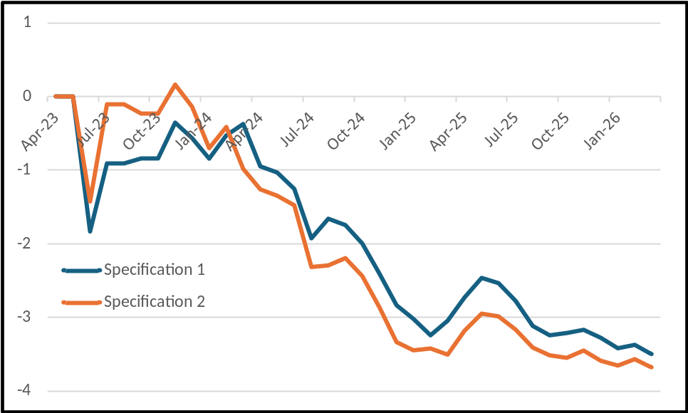

*** Regression results to be added later ****
Notes: The figure plots month fixed effects from the main regressions, normalized to November 2022. The table reports companion regressions that replace month effects with a linear month trend; all other controls remain. Annual decline = 1 − exp(12 × monthly trend). All cluster-based p-values and confidence intervals use a t distribution with G − 1 degrees of freedom. The descriptive slopes through the plotted effects imply 57.4% and 63.6% annual declines. The first eight months (November 2022–June 2023) contain one observation each, so those month effects are mechanically determined and their clustered standard errors are correspondingly small; the plotted interval is therefore narrowest where the data are thinnest. The slopes through the month effects are descriptive and sensitive to those months, which is why inference relies on the one-step trend regressions in Panel B.

Exhibit 6: Subperiod Regression Results **** UPDATE ****
Variable | Period 1  Spec. 1 | Period 1  Spec. 2 | Period 2  Spec. 1 | Period 2  Spec. 2
Constant | 2.779*** (0.588) | -0.118 (0.909) | 1.501*** (0.431) | 2.027*** (0.563)
Ln(MMLU Pro) | 3.599*** (0.762) | 2.525*** (0.527) | 2.925*** (0.902) | 4.423*** (1.205)
Open Source | -0.718 (0.575) | -0.695* (0.383) | -0.833*** (0.301) | -1.018** (0.431)
Frontier | 0.865* (0.413) | 1.026** (0.432) | 0.927** (0.361) | 0.582** (0.225)
Developer fixed effects | No | Yes | No | Yes
Month fixed effects | Yes | Yes | Yes | Yes
Ln(1 + Model Age) | 4.110** (1.521) | 2.687*** (0.749) | 0.325 (0.866) | -0.204 (0.993)
Observations | 168 | 168 | 920 | 920
R-squared | 0.689 | 0.895 | 0.323 | 0.619
Panel A notes: Period 1 is Nov. 2022–Dec. 2024; Period 2 is Jan. 2025–Mar. 2026. Frontier is reassigned within each subperiod. Developer-clustered standard errors are in parentheses; tests use a t distribution with G − 1 degrees of freedom.
Period | Model | Monthly trend | Clustered SE | Annual decline | N | Clusters
Period 1 | Specification 1 | -0.108* | (0.060) | 72.5% | 168 | 14
Period 1 | Specification 2 | -0.064 | (0.054) | 53.7% | 168 | 14
Period 2 | Specification 1 | -0.057* | (0.031) | 49.5% | 920 | 29
Period 2 | Specification 2 | -0.028 | (0.035) | 28.7% | 920 | 29
Panel B notes: Companion H3 regressions replace month fixed effects with a linear month trend. Tests use a t distribution with G − 1 degrees of freedom. * p < .10, ** p < .05, *** p < .01.

Exhibit 7: Monthly Frontier-Premium Estimates [**** Delete ****]

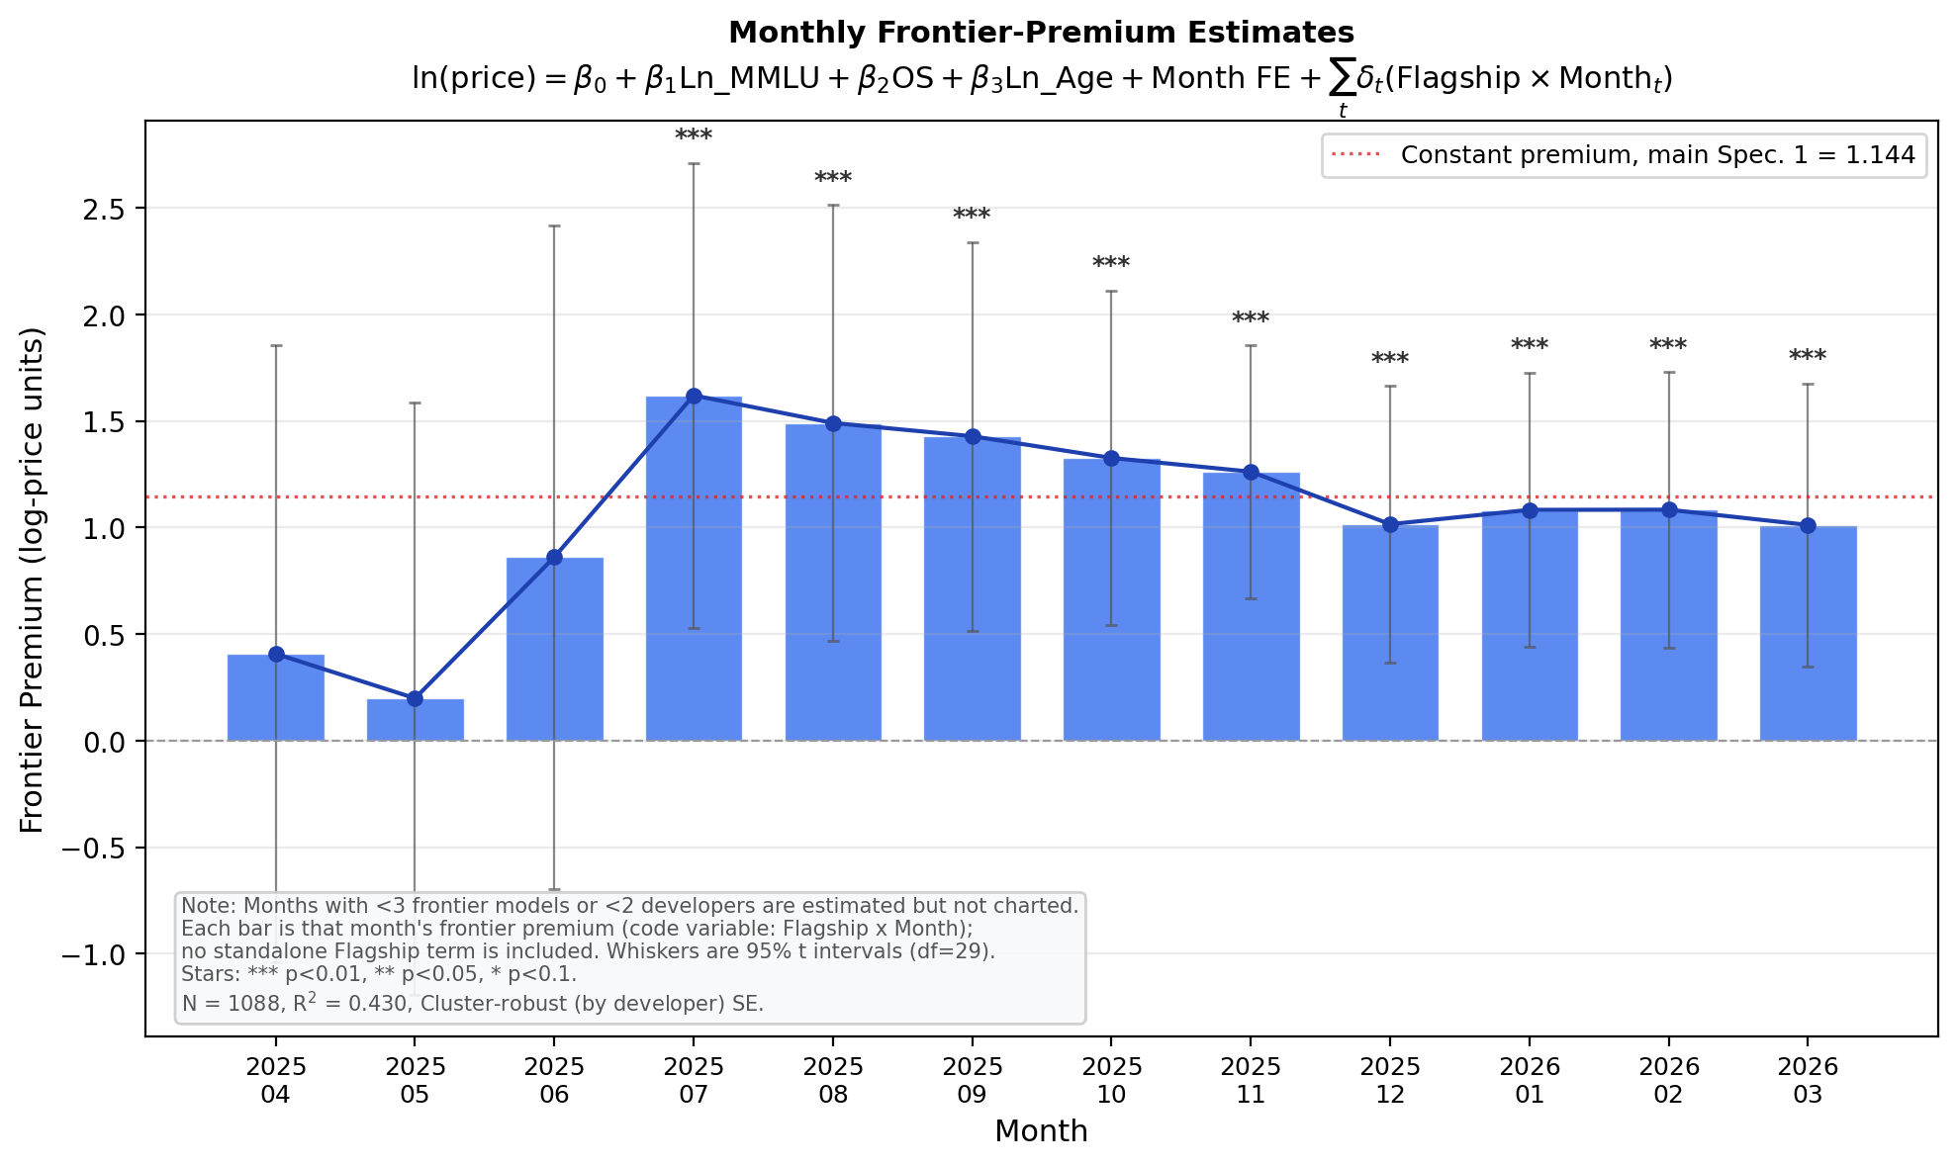
Each bar is the estimated monthly Frontier × Month coefficient. Months with fewer than three frontier models or fewer than two developers are not charted. The estimates vary substantially and are not used to claim a monotonic decline.

Exhibit 8: Number of Frontier Models per Month [*** Delete]

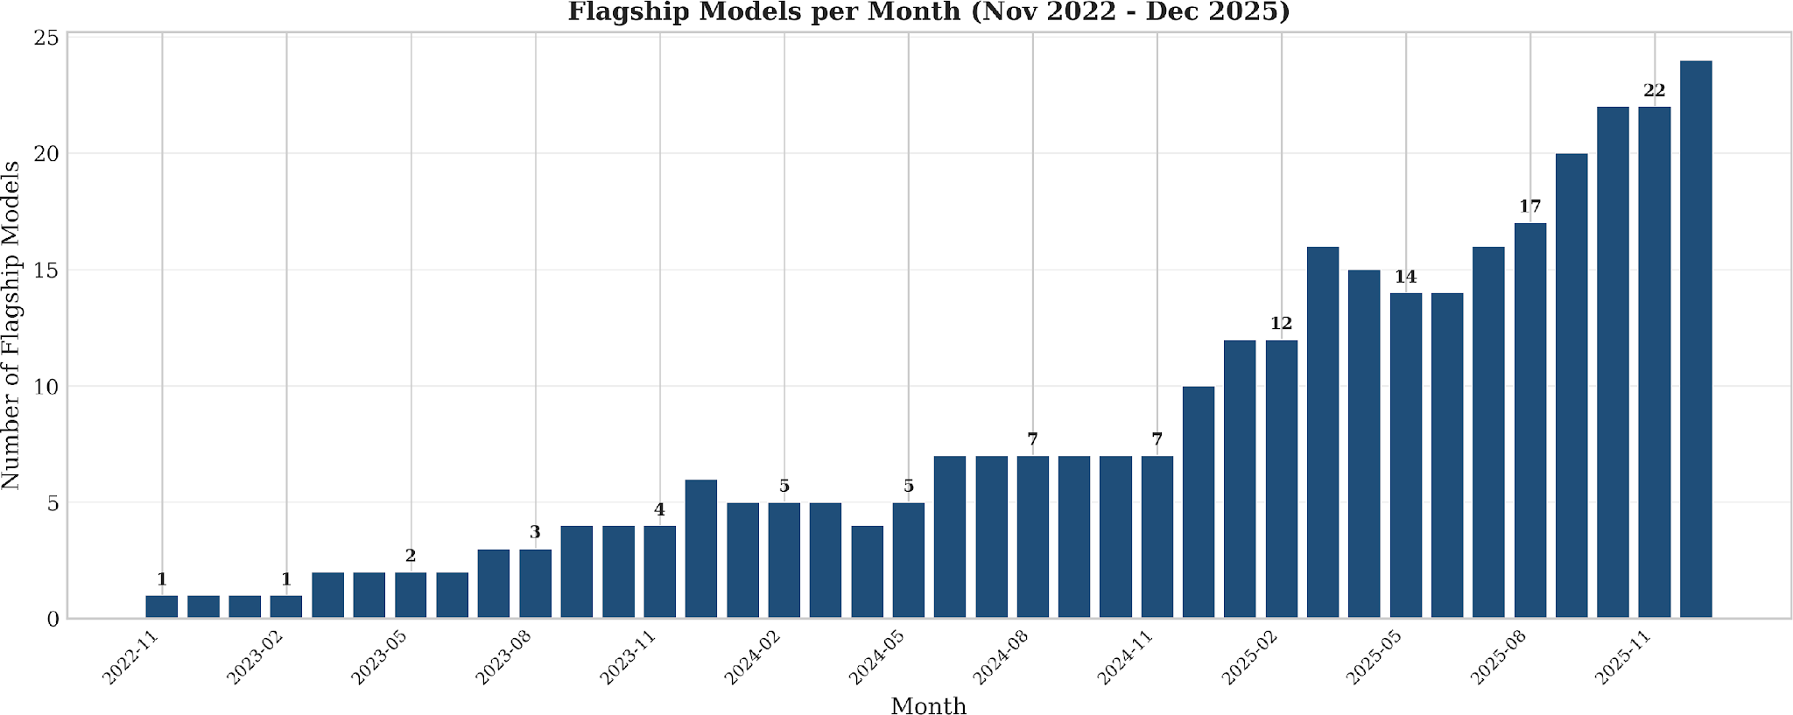
This pre-existing display is retained for the later author pass.

Exhibit 9: Additional Regression Models [to be reviewed later] **** Delete ****

Model | Key Variable | Coefficient | Clustered SE | R-squared
Price Deflation (capability-adjusted) | Month index | -0.091*** | (0.021) | 0.279

MMLU Pro Elasticity + OS | Ln(MMLU Pro) | 1.508*** | (0.362) | 0.261
 | Open Source | -1.020** | (0.379)
Intelligence Elasticity | Ln(Intelligence) | 1.168*** | (0.335) | 0.140
Intelligence + OS | Ln(Intelligence) | 0.814** | (0.377) | 0.235
 | Open Source | -0.988** | (0.432)
Notes: Recomputed on the 12-month estimation sample (N = 1,088; N = 1,077 for the Intelligence Index rows, which lack 11 observations) with developer-clustered standard errors and a t distribution with G − 1 degrees of freedom. * p < .10, ** p < .05, *** p < .01. These are pooled models without month or developer fixed effects, deliberately simpler than the main specifications; the capability-adjusted trend row echoes Exhibit 5's H3 estimates in minimal form. Without the capability control, the raw price trend is −0.011 (SE 0.027) and indistinguishable from zero: posted prices fall only capability-adjusted.

Exhibit 10: Within-Developer Residual Autocorrelation [retained for later author pass] *** Delete ****
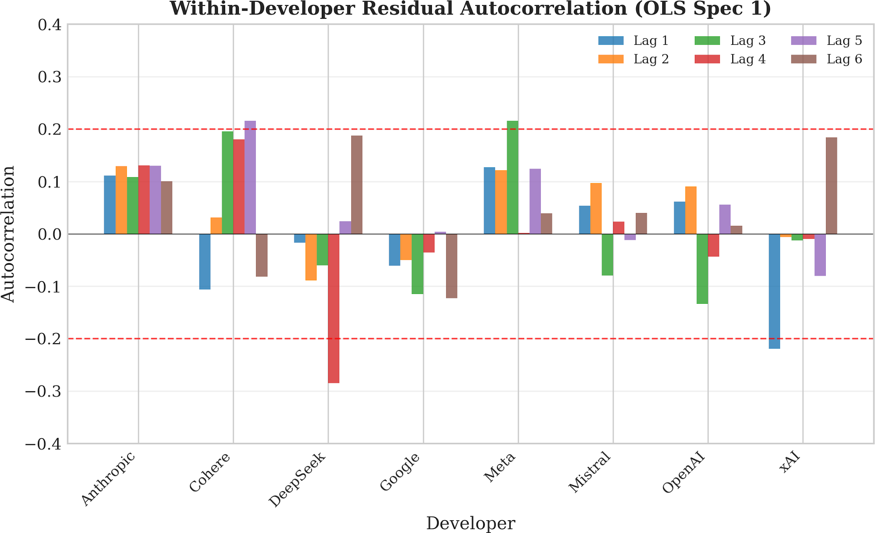
This pre-existing display is retained for the later author pass. The current paper reports standard errors clustered by developer.

